**The Abbey Theatre**

The Abbey Theatre is a term that has come to encapsulate the many iterations of the National Theatre of Ireland. Located in Dublin, the Abbey Theatre was originally and literally the name of a building purchased in 1904 by the theatre’s English patron Annie Horniman. The precursor of the Abbey was the Irish Literary Theatre (ILT), founded in 1897 by Lady Isabella Augusta Gregory, Edward Martyn, George Moore, and W. B. Yeats. Like many modernist movements and institutions, the ILT articulated its aims in a founding manifesto that announced the intention to stage ‘certain Celtic and Irish plays’ and to embody ‘that freedom to experiment which is not found in theatres of Europe and without which no new movement in art and literature can succeed’ (Gregory 9). In 1902, the ILT merged with the acting company of W. B. Fay’s Irish National Dramatic Company, and in 1903, this company was named the Irish National Theatre Society. In 1906, it became the National Theatre Society, Ltd., a professional company under the directorship of Gregory, Yeats, and J. M. Synge. The Abbey remains today the national theatre of Ireland, and also houses the smaller, experimental Peacock Theatre.

Early Abbey productions were largely a mix of native peasant plays and heroic dramas penned by Gregory, Synge, Yeats, and other Irish playwrights, including Padraic Colum, Douglas Hyde, and Lennox Robinson. The theatre offered audiences a smattering of translated classics as well as the occasional modernist drama by European playwrights such as Hauptmann or Strindberg. In the 1920s, the Abbey famously premiered Sean O’Casey’s Dublin Trilogy, which dramatized contemporary Irish political events. When the Abbey became the official state theatre in 1925, traditional realist drama commanded the stage, but an innovative playwright like Teresa Deevy could nonetheless find a place there for her critiques of Irish culture. In the 1960s, the Abbey emerged from what is generally understood as a creatively fallow period with the work of Brian Friel, Thomas Kilroy, and Tom Murphy. Like more recent Abbey playwrights, including Marina Carr, Frank McGuinness, and Mark O’Rowe, these dramatists draw themes, forms, and practices from native and international modernisms.

During its history, the Abbey notoriously rejected several experimental plays, including O’Casey’s expressionist drama *The Silver Tassie* (1928) and Denis Johnston’s Pirandello-esque satire *The Old Lady Says ‘No!’* (1929). Nonetheless, the theatre harnessed many innovative modernist practices to promote its aims. For instance, the early Abbey published a series of little magazines edited by Yeats, and the shocking content of Synge’s *The Playboy of the Western World* (1907) and O’Casey’s *The Plough and the Stars* (1926) inspired audience riots. The company’s first American tour in 1911 is credited with helping to inspire the American Little Theatre Movement. The Abbey’s enduring commitment to innovation is also evident in its performance practices: Japanese Noh powerfully influenced Yeats’s drama, and the dancer Ninette de Valois, who performed with the Ballets Russes, established the Abbey Theatre School of Ballet in 1927. In the late 1930s, the set and costume designer Tanya Moiseiwitsch helped to nudge the Abbey away from theatrical naturalism into more modern visual representations.

**List of Works [key primary and documentary texts related to the Abbey]**

Fay, Gerard. (1958) *The Abbey Theatre: Cradle of Genius*, London: Hollins and Carter.

Fay, W. G., and Catherine Carswell. (1935) *The Fays of the Abbey Theatre: An Autobiographical Record*, New York: Harcourt Brace.

Gregory, Lady Isabella Augusta. (1965) *Our Irish Theatre* (1913), New York: Capricorn Books.

Hogan, Robert, gen. ed. (1975-1979) *Modern Irish Drama: A Documentary History*, vols. 1–4, Dublin: Dolmen Press. Vol. 1, *The Irish Literary Theatre 1899-1901*, eds. Robert Hogan and James Kilroy. Vol. 2, *Laying the Foundations 1902-1904*, eds. Robert Hogan and James Kilroy. Vol. 3, *The Abbey Theatre, The Years of Synge 1905-1909*, eds. Robert Hogan and James Kilroy. Vol. 4, *The Rise of the Realists 1910-1915*, eds. Robert Hogan, Richard Burnham, and Daniel P. Pottet. Vol. 5, Vol. 6, *The Years of O’Casey*, eds. Robert Hogan and Richard Burnham.

Hunt, Hugh. (1979) *The Abbey: Ireland’s National Theatre, 1904-1979*, New York: Columbia University Press.

Nic Shiubhlaigh, Maire (and Edward Kenny). (1955) *The Splendid Years*, Dublin: James Duffy.

Robinson, Lennox. (1951) *Ireland’s Abbey Theatre: A History 1899-1951*, London: Sidgwick and Jackson.

Saddlemyer, Ann (ed.) (1982) *Theatre Business: The Correspondence of the First Abbey Theatre Directors: William Butler Yeats, Lady Gregory, and J. M. Synge*, University Park: Penn State University Press.

**References and Further Reading**

**Davis, Alex. (2009) ‘Yeats and the Celtic Revival: *Beltaine* (1899-1900), *Samhain* (1901-8), *Dana* (1904-5), and *The Arrow* (1906-9)’,** *The Oxford Critical and Cultural History of Modernist Magazines, vol. 1, Britain and Ireland 1880-1955*, Oxford: Oxford University Press. 152-175.

Frazier, Adrian. (1990) *Behind the Scenes: Yeats, Horniman, and the Struggle for the Abbey Theatre*, Berkeley: University of California Press.

Harris, Susan. (2002) *Gender and Modern Irish Drama*, Bloomington: Indiana University Press.

Morash, Christopher. (2002) *A History of Irish Theatre, 1601-2000*, Cambridge: Cambridge University Press.

Pilkington, Lionel. (2001) *Theatre and the State in Twentieth-Century Ireland: Cultivating the People*, London: Routledge.

Reynolds, Paige. (2007) *Modernism, Drama, and the Audience for Irish Spectacle*, Cambridge: Cambridge University Press.

Trotter, Mary. (2001) *Ireland’s National Theatres: Political Performance and the Origins of the Irish Dramatic Movement*, Syracuse: Syracuse University Press.

Welch, Robert. (1999) *The Abbey Theatre 1899-1999: Form and Pressure*,Oxford: Oxford University Press.

**Paige Reynolds, College of the Holy Cross**

**Recommended Illustrations**

**[Note: please use all or as many of these as possible; if not, the image of the current Abbey building and the production photo of Tom Murphy’s *The House* are lower priorities.]**

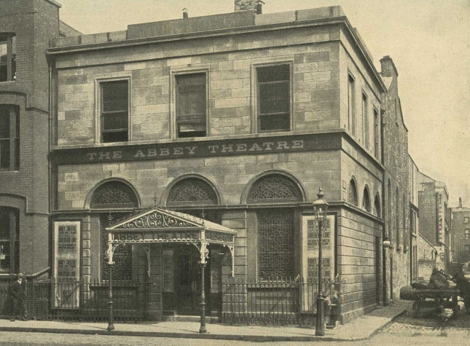

**The original Abbey Theatre building.**

[Available at: <http://www.abbeytheatre.ie/behind_the_scenes/article/history> ]

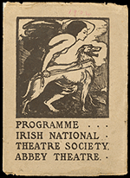

**Irish National Theatre Society Programme. The cover is emblazoned with a woodcut featuring the Irish mythic figure Queen Maeve and an Irish wolfhound, designed by Elinor Mary Monsell.**

[Available at: <http://rarebooks.library.nd.edu/collections/irish_studies/abbey_theatre.shtml>]

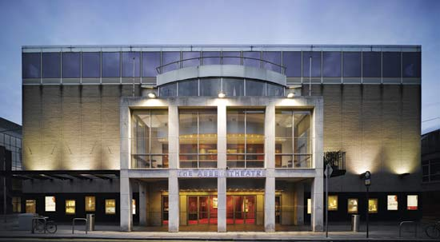

**The current Abbey Theatre building.**

[Avaialble at: <http://www.irishcentral.com/roots/historic-dublin-abbey-theatres-document-archives-get-published-online-175389381-237755281.html> ]

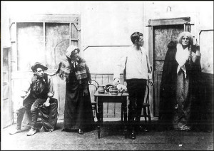

**The 1902 production of Lady Augusta Gregory and W. B. Yeats’s *Cathleen ni Houlihan* starring Maud Gonne and staged at St. Teresa's Hall by W. G. Fay's Irish National Dramatic Company.**

[Available at: <http://www.nlu3a.org.uk/yeats-14th-february/> ]

Aonghus Og McAnally, Darragh Kelly, Declan Conlon and Frank Laverty in the Abbey Theatre production of THE HOUSE by Tom Murphy, directed by Annabelle Comyn. On the Abbey stage, Thursday 7 June to Saturday 14 July 2012. Pic by Anthony Woods.


**Tom Murphy’s *The House*, Abbey Theatre, 2012.**

[Available at: <http://www.abbeytheatre.ie/people/view/aonghus_og_mcanally> ]

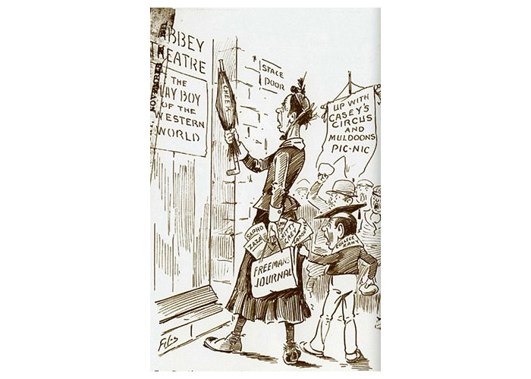

**A cartoon mocking the 1907 *Playboy* *of the Western World* riots.**

[Available at: <https://hal.arts.unsw.edu.au/events/modernism-workshop-j-m-synges-the-playboy-of-the-western-world-1907/> ]